Dinner in the Grove
Dinner in the Grove Sponsorship & Underwriting Opportunities

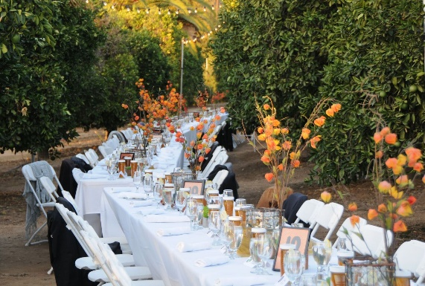
Orange Grove Sponsor - $10,000
- All the benefits of the Orange Festival Sponsorship, plus
- Two additional patron tickets (10 total) to event

Orange Festival Sponsor - $7,500
- All the benefits of the Orange Tree Sponsorship plus
- Two additional patron tickets (8 total) to event

Orange Tree Sponsor - $5,000
- All the benefits of Orange Blossom Sponsorship, plus
- Two additional patron tickets (6 total) to event
- Name & logo on Citrus/Cajon Street Banner (if received by the August 1st deadline)

Orange Blossom Sponsor - $2,500
- All the benefits of Gold Label Underwriter, plus
- Name & logo on all signage for the Dinner in the Grove
- Logo and acknowledgment on website
- Two additional patron tickets (4 total) to event

Gold Label Underwriter - $1,000
- All the benefits of Silver Label Underwriter, plus
- Two patron tickets to event (includes special seating)

Silver Label Underwriter - $500
- Special signage at event
- Listing in event program

Other Amount $____________

Name: _________________________________________________________________________________________

Business name if applicable: ________________________________________________________________________

Address: ________________________________________________________________________________________

Phone: ___________________________ Email Address: _________________________________________________

Gift Amount $______________________

Credit Card #:___________________________________________ AMEX Discover MasterCard Visa

Expiration Date:__________________________________________

Signature:_______________________________________________

* Sponsors of $5,000 or above, please respond before August 1st due to banner printing deadlines

If you have any questions, contact Jill Prendergast at 909-793-2673 x 112 or by email to jill@redlandsfamilyservice.org.

Please contact our business regarding in-kind contributions.

Thank you for your gift. All donations to Family Service Association of Redlands are tax-deductible as allowable by law. (Tax ID# 95-1655614)

