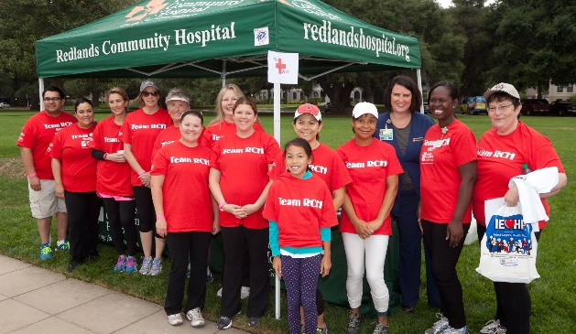****

**2023 Resource Table Form**

Redlands Hunger Walk 2023 will be held on June 3, 2023

on the University of Redlands campus.

*Resource tables will be set up in the Quad. Join this great opportunity to promote services and programs to the community. Giveaway items are encouraged, but no sales are allowed.*

In 2022, over 400 individuals participated in the 5K Walk

exploring the University of Redlands campus.

Kiwanis Noon Club will supply their famous pancake breakfast to all attendees. Walkers are given a commemorative t-shirt at check-in, and a goody

bag as they come across the finish line. If you cannot participate with a

table, you are welcome to add an item to the goody bag.

⃝ Yes, we would like to have a Resource Table at Redlands Hunger Walk 2023

One six-foot table and two chairs will be supplied, everything else is the responsibility of

the vendor. Set up starts at 7 a.m. on June 3rd, the Hunger Walk begins at 8 a.m., and is over

by 11 a.m.

⃝ We are unable to man a table, but would like to include an item in the goody bag given

to walkers at the event. We will supply Family Service with 350 - 500 items by May 19, 2023

⃝ Please contact me about a Partnership Gift.

Business/Organization Name:______________________________________________

Address:­­­­­­­­____­­­­_______________________________________________________­­­­­­­­­________

Contact Name(s):___________________________________________________________

Contact Phone Number(s):__________________________________________________

Email Address:_____________________________________________________________



612 Lawton Street, Redlands, CA 92374 (909) 793-2673 redlandsfamilyservice.org Fax (909) 793-7324